41.20: a) 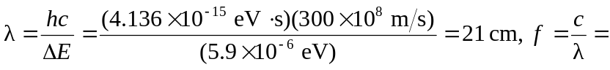
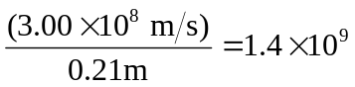Hz, a short radio wave.
b) As in Example 41.6, the effective field is 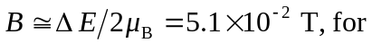smaller than that found in the example.

